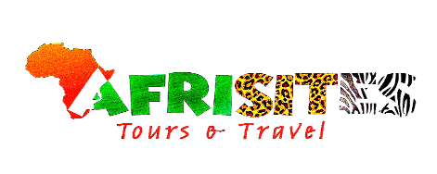

2-Day Gorilla Trekking Safari-Bwindi National Park

This 2-day gorilla trek is one of the last-minute option available for individuals to embark on gorilla trekking in Uganda within 2 days. The 2-day gorilla trek takes you to Bwindi Impenetrable National Park forests in southwestern Uganda to encounter the mountain gorillas in their natural habitat. The tour is scheduled to start with a pickup in Kigali, Rwanda, followed by a drive to Uganda.

ROUTE
Rwanda
Start | Kigali (Day 1)
Uganda
Day 1 | Bwindi Impenetrable NP (Gorillas)
Rwanda
End | Kigali (Day 2)

Tour Features

Mid-range tour
This mid-range tour uses lodges.

Private tour
This tour will be organized exclusively for you and won't be shared with others.

Can start any day
If availability permits, this tour can start on any day.

Can be customized
You can request changes to this tour.

Suitable for solo travelers
Solo travelers can book this private tour.

Minimum age of 15 years
The minimum age for this tour is 15 years.

Activities & Transportation
Activities: gorilla trekking

Getting around: open-sided 4x4 vehicle & pop-up roof 4x4 vehicle

A transfer from and back to the airport is included

Accommodation & Meals
- Additional accommodation before and at the end of the tour can be arranged for an extra cost
- Day Accommodation Meals
- Rushaga Gorilla Lodge Mid-range lodge just outside Rushaga (Bwindi Impenetrable NP)

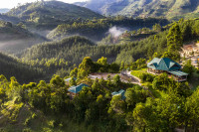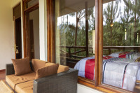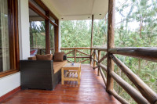

Lunch & Dinner Included
- 2 End of tour
(No accommodation)
Breakfast & Lunch Included

Day by Day

Arrival

You'll be collected from the airport.
- Accommodation before the tour starts can be arranged for an extra cost.

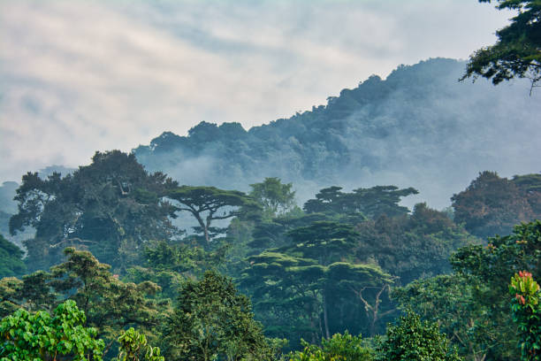

Day 1

Transfer from Kigali, Rwanda to Bwindi Impenetrable National Park in Uganda
Our representative will pick you up in Kigali and drive you to Bwindi Impenetrable National Park. The drive to Uganda will go through Rwanda's northern town of Ruhengeri. You will then cross over into Uganda via the Cyanika or Katuna border post. The trip continues through the nearby Kisoro or Kabale town and Bwindi National Park. The journey from Kigali to Bwindi National Park will take approximately 5 hours. You will arrive at Bwindi National Park in the early afternoon, with the option to engage in activities such as canoeing at Lake Mutanda, visiting the Batwa community, and experiencing coffee-making. Note: Before driving to Uganda, we can organize a complimentary Kigali city tour including a visit to the Genocide Museum.
Main Destination:
Bwindi Impenetrable National Park (Gorillas)
Best Time to Visit: June to August and December to February (Gorilla trekking is easiest)
High Season:
Best Weather: June to July and December to February (Less rainfall)
Accommodation:
Rushaga Gorilla Lodge
Mid-range lodge located just outside Rushaga (Bwindi Impenetrable NP)
Meals & Drinks:
Lunch & dinner (Breakfast not included)
Drinking water (Other drinks not included)

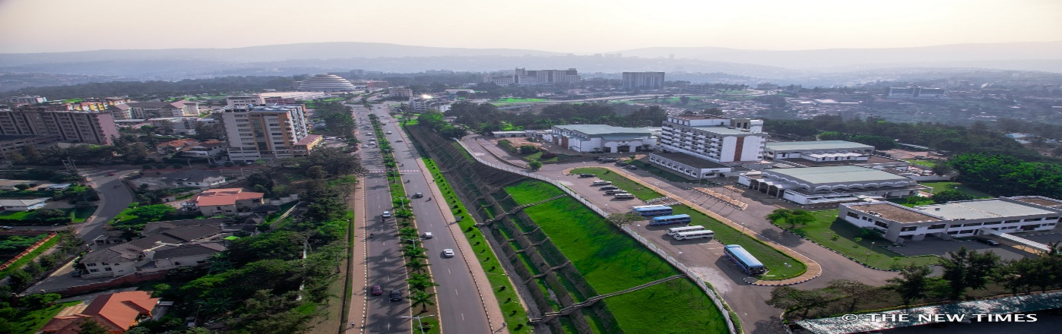

Day 2

Mountain Gorilla Trekking and Transfer to Kigali
You will proceed to the Bwindi National Park gate immediately after breakfast for a briefing about the gorilla trek. The national park guide will explain what to expect during the trek and assign you to a trekking group. Other visitors may also join you. The duration of the gorilla trek can vary, depending on the location of the gorillas within the forest. After completing the trek, you will transfer back to Kigali, Rwanda. Please note that since gorilla trekking can sometimes take more than 5 hours, it is advisable not to book a flight out of Kigali scheduled to depart before 10:00 p.m. local time. Note that Uganda's time zone (EAT) is one hour ahead of Rwanda's time zone (CAT).
Main Destination:
Kigali (Rwanda)
Accommodation:
No accommodation (End of tour)
Meals & Drinks:
Breakfast & lunch (Dinner not included)
Drinking water (Other drinks not included)
End of tour
Additional accommodation can be arranged at an extra cost.
You will be dropped off at the airport.

Rates
Important Information
Rates are per person and do not include international flights from or to your home country.
This tour is available for individuals aged 15 years and older.

Rates Per Person
Start dates | Solo1 room | 2+ people Sharing rooms
Jan 1, 2026 - Dec 31, 2027 | $1,750 | $1,580

Included
- Park fees (for non-residents)
- Gorilla permits (one per person, non-resident)
- All activities (unless labelled as optional)
- All accommodation (unless listed as upgrade)
- A professional driver/guide
- All transportation (unless labelled as optional)
- All taxes/VAT
- Roundtrip airport transfer
- Meals (as specified in the day-by-day section)
- Drinking water (on all days)
Excluded
- International flights (from/to home)
- Additional accommodation before and at the end of the tour
- Tips (tipping guideline: US$10.00 per person per day)
- Personal items (souvenirs, travel insurance, visa fees, etc.)
- Government-imposed increase of taxes and/or park fees

